CURRICULUM VITAE

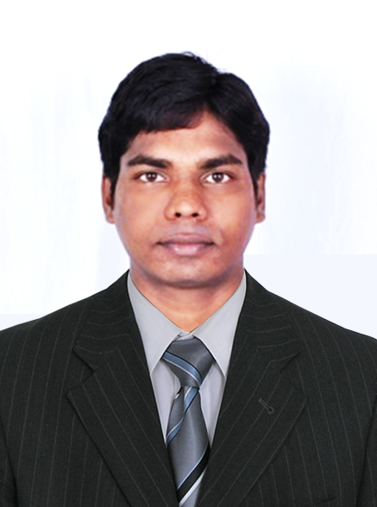PERSONAL PROFILE:

Name : Kopela Naresh
Date of Birth : 08-08-1989
Languages Known : English, Hindi, Telugu and Malayalam
Nationality : Indian (Passport No. K6431280)
Address : MP Colony, H No 19-5-59/2, Bhadrachalam,
Khammam District, Telangana, India –507111.
Phone : +91 9618170250, +96 6572382893(KSA)
Email address : nareshkopela822@gmail.com

Qualification | University/Board | Name of the Institute | Percentage  /CGPA | Year of  Passing
Post Graduate Diploma in Computer Application | Winsoft Educational Society (Regd. No. 191) | Winsoft Computer Education | 73.75 % | 2013
M.Sc.  (Biochemistry and molecular biology) | Central University of Kerala, Kerala | Central University of Kerala, Kasaragod | 6.29 CGPA | 2012
B.Sc.  (Biochemistry) | Andhra University, Andhra Pradesh | Mrs. A. V. N. College, Visakhapatnam | 59.17% | 2009
XII  Intermediate (Bi.P.C ) | Board of Intermediate | St.Paul”s Luthern Jr College Bhadrachalam | 71.9% | 2006
High School (X) | Board of Secondary Education | Don Bosco High School ,wyra | 62% | 2004
EDUCATIONAL QUALIFICATIONS:

WORK EXPERIENCE:

- Senior Aquaculture Specialist at National Aquaculture Group, Al lith, Saudi Arabia from September 2017 till date.
Supervising Algae Laboratory production Unit.

- Aquaculture Technician at Chareon Pokphand Group –CP Aquaculture, India from March 2014 to August 2017 (3 years and 6 months).
WORK EXPERTISE:
- Sea water and Fresh water disinfection and treatments
- Follow up Section Disinfection and preparation of dry outs
- Cultivation of live feeds (ALGAE and ARTEMIA)
- Larval management and health assessment
- Brood stock maintenance and conditioning[InternalTraining 3 month]
- Maturation and Natural spawning methods[InternalTraining 3 Months]
- Water quality management and water exchange protocols
- Periodical sampling of water and surface for Microbiological analysis
- Sampling of shrimps for Pathology and genetic analysis
- Periodical analysis of feed consumption and body weight (ABW)
- Packing and selling of seed to the costumers
Shrimp species handled: Lito Penneus Vennamei
Algae species: Chaetoceros Calcitrons, Thalassiosira Psuedonena, Thalassiosira Weissflogii.
Instruments Expertise: Indoor lab (Algae seed bank preparation and scale up of algae from Indoor lab to Race ways) Photo Bioreactor, Biophysical operators (Autoclave, Hot air oven, Laminar Air Flow, Microscope) Daily Algae Production around 300-500 Tons.
SKILLS:
- Excellent communication skills.
- Willingness to learn, interest to work with a team of experts.
- Self-motivated and enthusiastic personality.
- Basic Computer skills and expertise in MS Office.

CONFERENCES:

- International Conferences : 1
- National Conferences : 3

DECLARATION:
I hereby declare that the above furnished information is true and correct to the best of my knowledge.

Place: Al lith, Saudi Arabia.
Date: 11-1-2019. (KOPELA NARESH)

REFERENCE DETAILS:
Karthiga Kumanan
Aquaculture Technician
Karthiga. Kumanan@cawthron.org

Sandip Ahirrao,
Head-Marketing (Aqua Feeds),
Growel Feeds PVT LTD,
Chevur Village, Singarayapalem post,
Mudinepalli mandal, Krishna District , Andhra Pradesh.
Mobile: +918501003322,9840049868, Email: sandipahirrao@gmail.com

NB Vijayakumar Kallepalli,
Technical Consultant Aquatex ,
Aqua Farms ,Beliz
Mobile: +5016156366

Dr.Vaitheeswaran Tiruvengadam,
Assistant General Manager,
R&D Rarbio Energies
Chennai, India.
Mobile: +256702071260, Email: frs69@rediffmail.com

Dr. Rajendra Pilankatta,
Associate Professor,
Dept. of Biochemistry & Molecular Biology,
School of Biological Sciences (SBS),
Central University of Kerala,
Riverside Transit Campus, Padanakkad,
Kasaragod-671314, Kerala, India.
Mobile: 09846255358, Email: praj74@gmail.com

